Revision Notes

The Basics of Music Theory

Musical Forms:

There are 4 main types of Musical Forms,

* Binary Form (Two sections, A and B)
* Ternary Form (Three sections, A, B and returns to A)
* Rondo Form (A theme that alternates with other contrasting parts A,B,A,C,A)
* Theme and Variations (A main theme, followed by variations – A,A1,A2,A3)

Note Values:

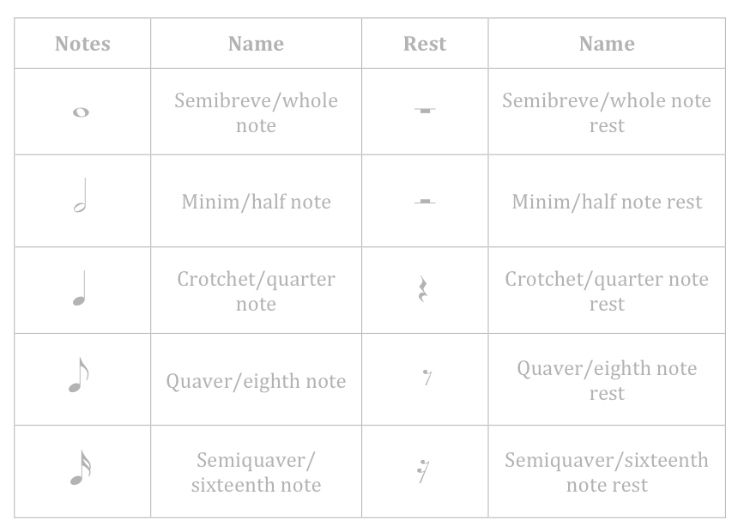

Time Signatures:

3

4

6

8

2

2

C

3 Crochets per bar

6 Quavers per bar

2 Minims per bar

Common time (4 Crochets per bar)

Musical Periods:

* Baroque (1600 – 1750) – Ornamented (decorated) melodies, Major or Minor (not modal), Diatonic (uses notes not in the key), Combination of textures, Basso Continuo, Terraced Dynamics (adding more instruments to increase volume)
* Classical (1750 – 1810) – Balanced Q&A phrases, Short forms (eg rondo, sonata), Diatonic harmony(chords/notes which relate to the key)
* Romantic (1810 – 1900) – Lush melodies, full woodwind section, Program Music (music which tells a story)
* Modern (1900-2000) – More diverse, minimalist, world music influences, expanded instrumental techniques

Orchestral Suite No. 2 – Badinarie (J.S Bach 1738/1739)

Badinarie is a baroque piece from the German composer Johan Sabastian Bach’s ***Orchestral Suite No. 2***written in 1738/39. Bach was known for his instrumental compositions, is regarded as one of the greatest composers. It is in the key of ***B minor,*** was written for ***flute, 2 violins, viola, and basso continuo (cello and harpsichord),*** it is in ***binary form,*** with Part A from bars from 0-16, and Part B 16-40.